**REVISION**

**1 Data security / SECURITY**

Data security is the practice of protecting digital information from unauthorized access, corruption, or theft throughout its entire lifecycle. It is a concept that encompasses every aspect of information security from the physical security of hardware and storage devices to administrative and access controls, as well as the logical security of software applications. It also includes organizational policies and procedures.

Operating systems have security. This is to prevent them from threats against: viruses, worms, malware, and hackers. Ways to prevent these threats can be installing antivirus software, inspecting incoming and outgoing network traffic through firewalls, using authentication and one-time passwords.

Network security consists of protection, detection, and reaction.

Protection – Ensure the correct configuration of your systems and network for protection.

Detection- you must be able to name the problem.

Reaction – you should find the problem quickly and respond to it.

**2)Operating system**

A piece of software which interacts directly with the hardware, manages resources, and usually presents a user interface to the user.

The purpose of operating system let us you use the interface.

An operating system is system software that manages computer hardware, software resources, and provides common services for computer programs.

An operating system has three main functions: (1) manage the computer's resources, such as the central processing unit, memory, disk drives, and printers, (2) establish a user interface, and (3) execute and provide services for applications software.

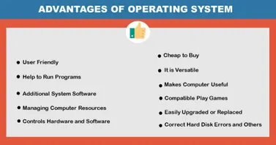

**3)Types of encryptions**

**Encryption**

The process of converting information or data into a code, especially to prevent unauthorized access.

Encryption is a process by which a message (called plaintext) is transformed into another message (called ciphertext) using a mathematical function and a special encryption password, called the key.

**Decryption**

It is the reverse process, from ciphertext to plaintext.

**Vigenère cipher**

To decrypt, take the first letter of the ciphertext and the first letter of the key. Go across from the key till you find your letter then go up to then plain text.

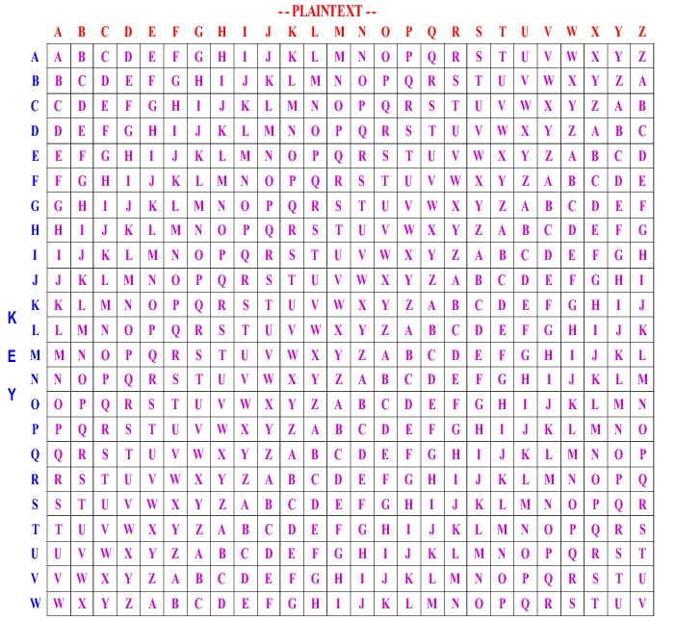

**4)Ceasar Cipher**

It is one of the earliest known and simplest ciphers.

works on letters from 1 – 26.

Shifts left 1 letter.

**Reasons why a Vigenère cipher is more secure than a Caesar cipher?**

1. Multi alphabetical
2. Each letter of the message shifts by a different amount
3. Generates a greater number of permutations for each letter
4. More resistant to frequency analysis
5. Repeated letters are disguised
6. More resistant to Bruce force attack

**5)Main factors affecting CPU performance**

**Clock speed**

Clock speed is used to measure how fast the CPU runs and fetches information. Clock speed is measured in hertz.

Measures how fast the CPU can run, relating to the amount of instruction cycles the CPU can deal with in a second.

The speed of the Fetch-Decode-Execute cycle is determined by the CPU’s clock chip. This chip uses a vibrating crystal that maintains a constant rate. The speed of the clock is measured in hertz (Hz) which is the number of cycles per second. A clock speed of 500Hz means 500 cycles per second. Current computers have CPU clock speeds of 3GHz which means 3 billion cycles per second. It is possible to increase the clock speed for a CPU, this is known as overclocking.

** The clock speed represents how much cycles per second can be executed. Can also be referred to as clock rate. Clock speed/Clock rate is measured in gigahertz (Ghz)

**Number of cores**

A single CPU core contains an ALU (Arithmetic Logic Unit) control unit and registers, however increasing the number of cores means the number of instructions can be increased. Although multiple cores still must communicate through channels meaning clock speed will not double / triple / etc.

**Size of cache**

Cache is used to store data and instructions that the processor will reuse. The larger a cache the more data that can be retained. CPUs can work very quickly but unfortunately only when supplied with data, to overcome this the CPUs cache memory will not just copy the instruction needed at that time, instead it will also copy the continuing instruction. Cache memory has read speeds like the CPU and is therefore much faster than RAM. So, to improve efficiency the CPU’s control unit will look first in the cache for the next instruction to see if it has already been copied, which reduces the time taken to access data.

** Cashe is used to store instruction and data that the processor will reuse. The larger a cashe the more data is holds.

**Cashe**

CPU can work very quickly indeed but unfortunately CPU’s can only work when supplied with data. The RAM cannot work at the same speed.

To overcome this the CPU’s cashe memory will not just copy the instruction needed at that time, instead it will also copy the continuing instruction.

Cashe memory has read speed like the CPU and is therefore much faster.

**6) Computer hardware**

Computer hardware includes the physical parts of a computer, such as the case, central processing unit, random access memory, monitor, mouse, keyboard, computer data storage, graphics card, sound card, speakers, and motherboard.

**7) Computer Software**

Software is a collection of instructions and data that tell a computer how to work. This contrasts with physical hardware, from which the system is built and performs the work. In computer science and software engineering, computer software is all information processed by computer systems, including programs and data.

**8)CPU**

A central processing unit (CPU), also called a central processor, main processor or just processor, is the electronic circuitry that executes instructions comprising a computer program. The CPU performs basic arithmetic, logic, controlling, and input/output (I/O) operations specified by the instructions in the program. CPUs are primarily responsible for retrieving and executing instructions.

**Kernel**

Kernel is the heart of the operating system.

Process management for application execution

Memory management, allocation, and I/O

Device management using device drivers

System call control, which is essential for the execution of kernel services

**interrupts**

Interrupts are a response by the processor to a process/event that needs immediate attention from the software.

Interrupts alert the processor and servers a request for the CPU to interrupt the currently executing program/code when permitted, in order so that the event can be processed within good time.

**9) Assistive IT technology**

Assistive technology is technology used by individuals with disabilities in order to perform functions that might otherwise be difficult or impossible.

**10)Factors affecting choices of hardware**

* **Ease of Use** – How simple and intuitive the device is to navigate and perform tasks on. An inexperienced IT user may choose a device that is simple for them to use, or they’re more experienced with.
* **Performance** – How powerful the device is, such as processing, memory, graphics & storage. Someone purchasing a system for high-end gaming may priorities a device that has excellent performance.
* **Availability** – How often the device can be used, such as whether the device can be always on. A company purchasing an IT system for hosting their website will want it 24/7.
* **Accessibility** – How available the device is to be used by someone with a disability. Someone with a visual impairment may choose a device that uses adaptive technology to support them.

**11) Features of software and hardware affecting the performance of the system**

- The speed and width of the system's address and data buses.

- The model, clock speed, and the size of the internal memory cache of the system's CPU or CPUs

- The size of the level-two (L2) cache memory which is external to the CPU.  
- The amount of memory, the width of its data path, and its access time.

- Access time for hard disks

**12) Back up IT/Data recovery**

In information technology, a backup, or data backup is a copy of computer data taken and stored elsewhere so that it may be used to restore the original after a data loss event.

**Incremental Backups:**

Incremental backups are security copies that contain only files that have been modified since the last full backup. By using incremental backups, all the data first must be backed up in a full backup first. Therefore, each backup contains less data and is more efficient.

**Differential Backups:**

Data backups performed differentially include the entire change history of the files that have been created, updated, or otherwise altered since the last full backup, rather than copying all the data every time. It is this method to perform a full back up at the start, followed by successive backups that reflect any changes. This could also be done with a weekend full backup followed by daily differential backups.

This has several advantages:

* It is faster to back up than to make a full backup.
* Compared to incremental backups, restore is faster.
* Compared to full backup, the storage needs are lower

**13)Relational Databases, Advantages and Disadvantages of using these over flat files.**

Relational databases allow data to be separated and connected across several tables. Tables are connected through primary and foreign keys to increase efficiency.

2a)3 explain one way the read/write speed of RAM aids computer performance when playing games

You’re more likely to notice the impact of a slower drive than you are to notice whether the data is being encrypted.

2b)3 Myra wants to improve the performance of her computer

Explain what overclocking means?

overclocking is taking a computer component such as a processor and running at a specification higher than rated by the manufacturer. In other words, you can run your computer harder and faster than it was designed to run if you overclock it

2d) Give 4 reasons why a vignere is better than cypher ceaser ?

1. Multi alphabetical
2. Each letter of the message shifts by a different amount
3. Generates a greater number of permutations for each letter
4. More resistant to frequency analysis
5. Repeated letters are disguised
6. More resistant to Bruce force attack

2e)6 analyse the role of interrupts in computer games?

An [interrupt](https://www.computerscience.gcse.guru/glossary/interrupt) is a signal which is sent from a device or from software to the operating system.

The interrupt signal causes the operating system to temporarily stop what it is doing and ‘service’ the interrupt.

The [interrupt handler](https://www.computerscience.gcse.guru/glossary/interrupt-handler) is the part of the operating system which is responsible for dealing with interrupt signals.

Interrupts allow computers to give the impression they are multitasking.

2f)4 describe how a firewall prevents unauthorized access to data from outside the company

describe how a firewall prevents unauthorized access to data from outside the company A firewall acts as a barrier or filter between your computer and another network such as the internet.

A firewall only welcomes those incoming connections that it has been configured to accept. It does this by allowing or blocking specific data packets — units of communication you send over digital networks — based on pre-established security rules